**Level 1: PC Tower Case**

**Outline**

Learn about the internals of a standard PC case by examining physical samples and selecting and labeling images found on-line. Gain deeper knowledge by researching and reporting on specific components.

**Questions**

1. Find one (or more) images that clearly show the internals of a PC Tower Case.   
   (i.e. Google images using keywords “PC Case Internals”)

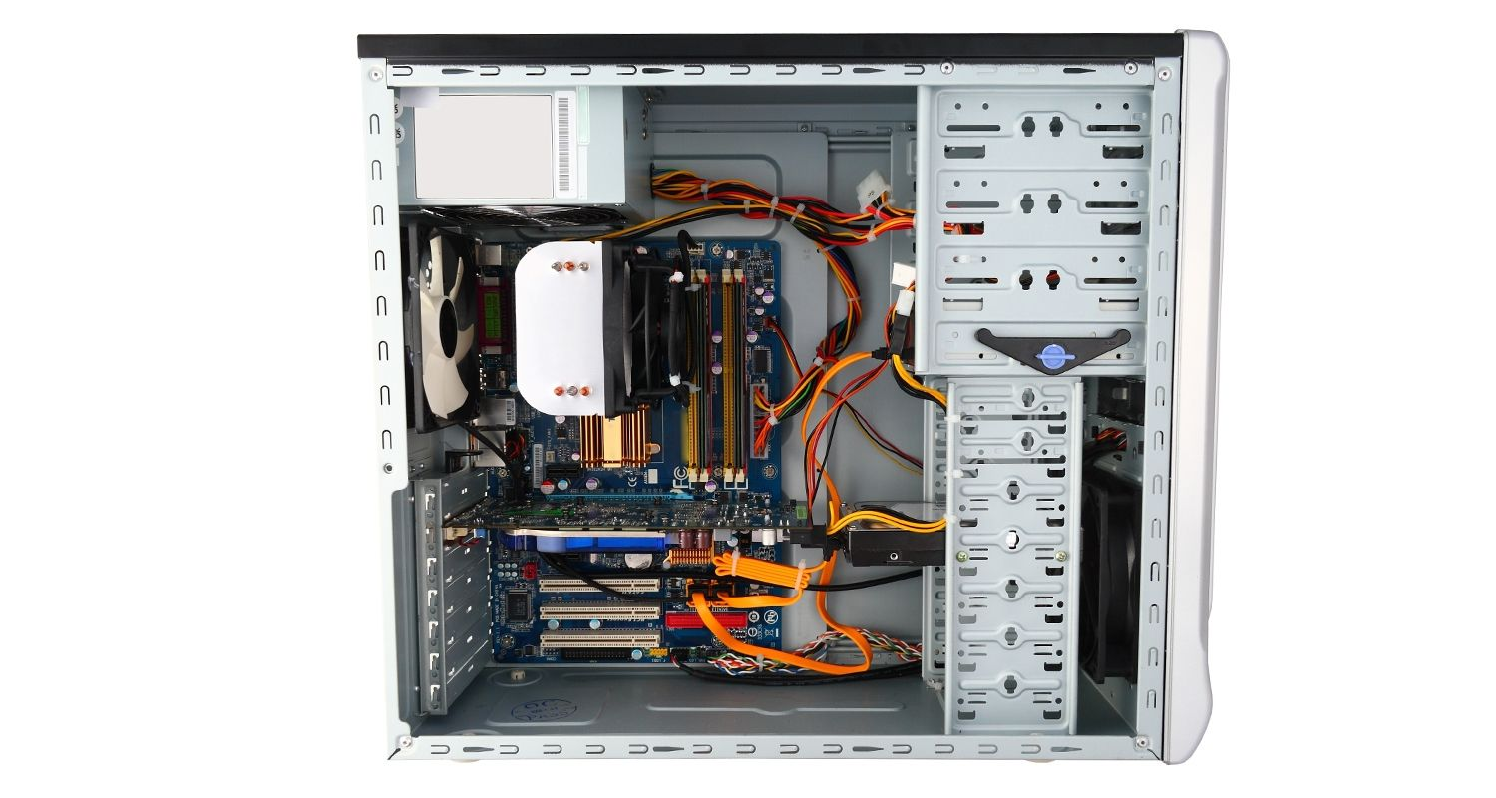

1. Clearly label the following components (using arrows) on your image of the PC case internals:
   1. Motherboard
   2. Power Supply
   3. Hard Disk Drive
   4. Optical Disk Drive (e.g. DVD)
   5. USB Expansion Ports
   6. Monitor Port
   7. Audio Ports
   8. Ethernet Port
   9. Cooling Fan

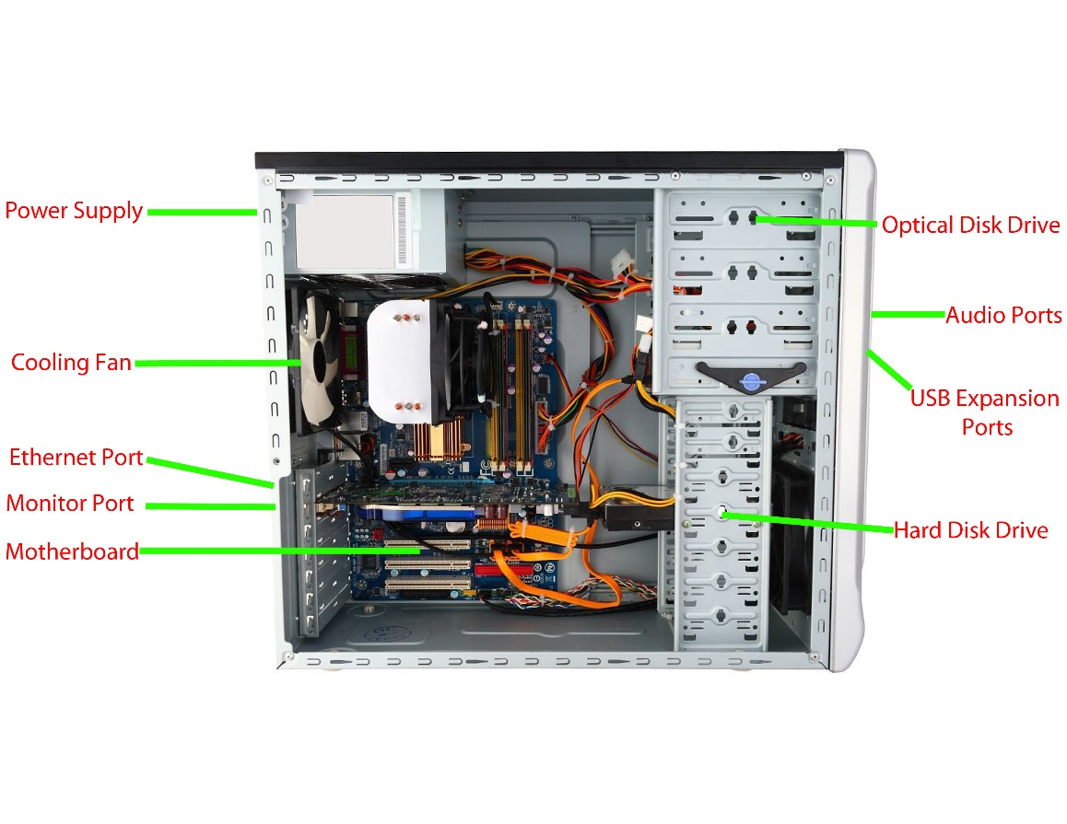

1. Research more in-depth about “Motherboards”. Make notes on the following:
   1. What different versions are currently available (speed and capacity)?

There are 4 different versions of the motherboard. One being the AT Motherboard with a speed of 100MHz and a capacity of 16GB. Another is the ATX motherboard with a speed of 200MHz and a capacity of 32GB. Also, the BTX motherboard which is faster than the ATX and has a greater capacity. Another Motherboard is the mini ITX.

* 1. How the component has changed since the 1980’s  
     Before the invention of the microprocessor, the cup contained many different motherboards indifferent functions. Overtime one motherboard ewes able to perform more and more functions. The AT motherboard was able to perform many functions. When new motherboards were invented, they were become faster and faster, they also had more capacity. Newer motherboards are becoming smaller with the same speed.

1. Research more in-depth about “Hard Disk Drives”. Make notes on the following:
   1. What different versions are currently available (speed and capacity)?

There are 4 types of Hard Disk Drives. One of the dives is the IDE drive with a speed of 133MB/s and a capacity of 2.1GB to 137GB. Another drive is the SATA with a speed of 600MB/s and a capacity of 500GB to 8TB. The third drive is the SCSI with a speed of 640MB/s and a capacity of 300GB. The last drive is the SAS drive with a speed of 6GB/s and a capacity of 6TB.

* 1. How the component has changed since the 1980’s  
     Hard Disk Drives started out very big and very slow. The speed was not that fast compared to the Drives of today. The older drives were physically very large. Drives started to become faster and they could hold more data. The invention of the Microdrive changed the hard disk drive market, this drive was small but had the speed and capacity of some older drives. The latest hard disk drives today can hold more than 5TB of data and are very fast to transfer data.

**NOTE:**

* Download the on-line version of this module (from the class GitHub repository)
* Questions for Level 2 and Level 3 are in the on-line version of this module
* Provide your answers in a MS Word, PowerPoint, or equivalent format
* Upload your answers to your personal GitHub repository

**Level 2: PC Motherboard**

**Outline**

Learn about the structure of a standard PC motherboard by examining physical samples and selecting and labeling images found on-line. Gain deeper knowledge by researching and reporting on specific components.

**Questions**

1. Find one (or more) images that clearly show the layout of a PC Motherboard.   
   (i.e. Google images using keywords “PC Motherboard”)  
   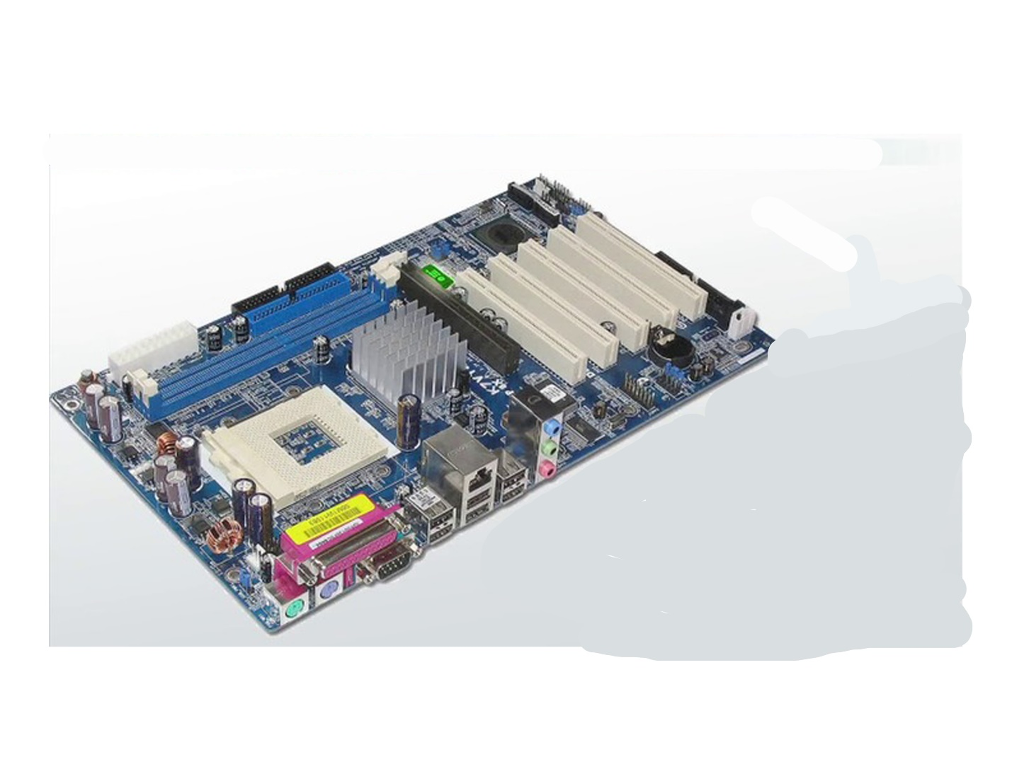
2. Clearly label the following components (using arrows) on your image of the PC motherboard:
   1. CPU (and fan)
   2. RAM Memory
   3. Disk Drive Interface (IDE or SATA)
   4. GPU Graphics Processor (either on-board or Graphics Card)
   5. Sound Processor (either on-board or Sound Card)
   6. Wi-Fi / Ethernet Network Interface (either on-board or Graphics Card)

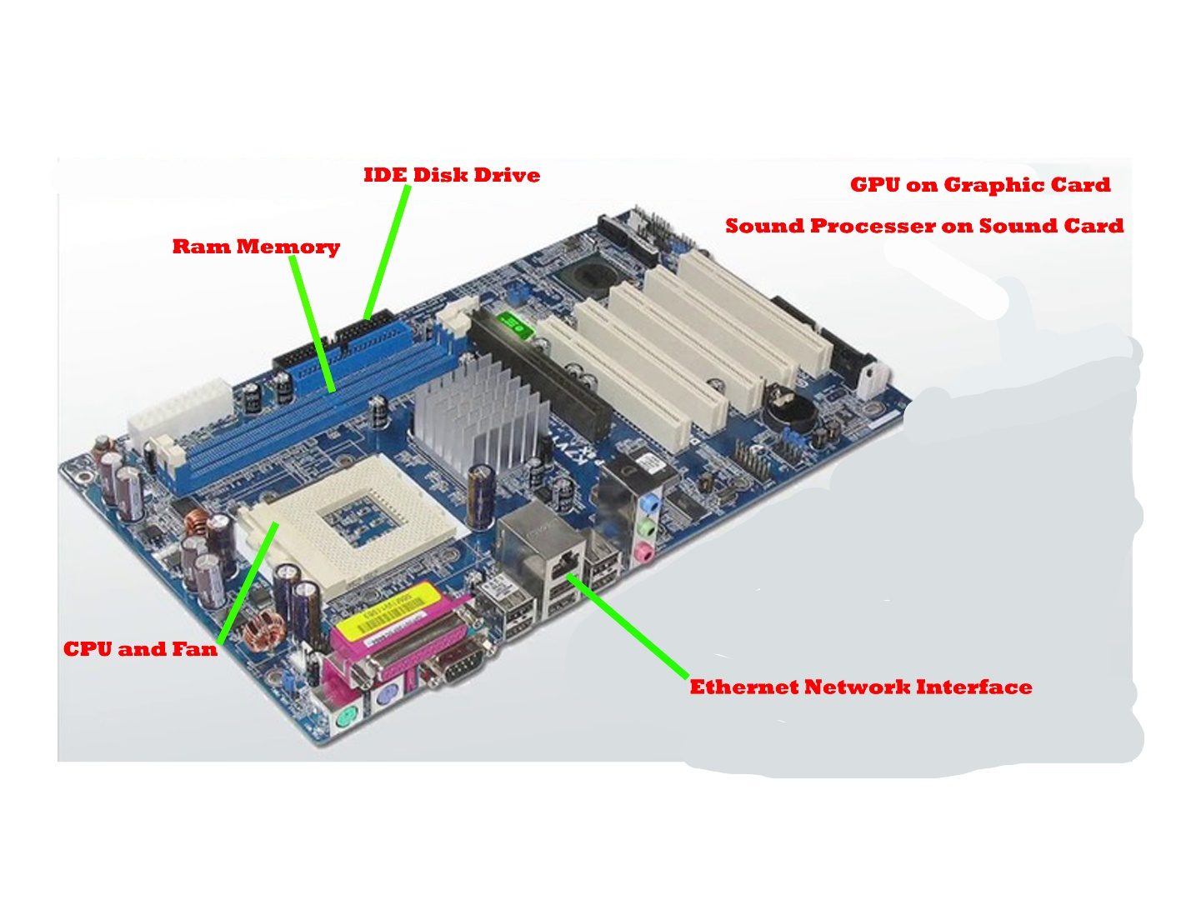

1. Research more in-depth about “CPU Processor Chip”. Make notes on the following:
   1. What different versions are currently available (speed and capacity)?

There are 6 different versions of CPU Processor Chips that are popular in the tech industry. One chip is the AMD Sempron with a speed of 2.9Ghz and the capacity depends on the motherboard. Another chip is the AMD Athlon with a speed of 2.33Ghz and the capacity depends on the motherboard. The third chip is the AMD Opteron with a speed of 3.5Ghz and the capacity depends on the motherboard. The fourth chip is the Intel Celeron with a speed of 3.6Ghz and the capacity depends on the motherboard. The fifth one is the Intel i9 with a speed of 3.6Ghz and the capacity depends on the motherboard. The last chip is the Intel Pentium with a speed of 3.8Ghz and the capacity depends on the motherboard.

* 1. How the component has changed since the 1980’s

CPU Processor Chips started out very big and slow and they produced a lot of excess heat. For example, the first intel chip was the 4004 with a speed of 740khz, which is way slower that some processer chips used in today’s computers. Intel also introduces the microprocessor, which was a game changes meaning it was small but had the same speed and power as some of the older and bigger processers. In the 1980s, custom build your own computer was not a thing and the sperate processer chips were very expensive. When more chips were being invented by different companies, the processer chips became more affordable to the public. This meant they could customize their PCs.

1. Research more in-depth about “RAM Memory”. Make notes on the following:
   1. What different versions are currently available (speed and capacity)?

There are 5 different versions of RAM that are available in the Tech market. One type of RAM is SDR SDRAM or Single Data Rate Synchronous Dynamic RAM with a speed of 133MT/s and sizes available are 16mb, 32mb,64mb, 128mb, 512mb, 1Gb, 2Gb, 4Gb and 8Gb. The second is DDR SDRAM or Double Data Rate Synchronous Dynamic RAM with a speed of 400MT/s and there are various sizes and capacities. Another version of RAM is the DDR2 SDRAM or Double Data Rate2 Synchronous Dynamic RAM with a speed of 800MT/s and there are various sizes and capacities. The fourth RAM is the DDR3 SDRAM or Double Data Rate3 Synchronous Dynamic RAM with a highspeed of 1600MT/s there are various sizes and capacities. The last type of RAM is the DDR4 SDRAM or Double Data Rate4 Synchronous Dynamic RAM with a speed of 2666MT/s and there are various sizes and capacities. All these types of RAM are compatible with the following sizes: 16mb, 32mb,64mb, 128mb, 512mb, 1Gb, 2Gb, 4Gb and 8Gb.

* 1. How the component has changed since the 1980’s  
     RAM started out to be very slow and it took a long time to access files on a computer, but overtime RAM became faster with more storage space. SRAM was a slow form of RAM it did not a lot of memory space. Then DRAM was invented, this had a lot more space and It was faster than SRAM. One of the fastest types of RAM is the DDR4, this RAM is way faster than the older RAMs, DDR4 also had more capacity with 8Gb of storage in one piece. RAM also used to be a lot bigger and took up a lot of space to be used. But now RAMs can be small as 30 cm in length and they could be faster than some older RAMs.

**Level 3: Peripheral Devices**

**Outline**

Learn about how peripheral devices are connected to the back side of a typical PC tower case. Examine physical samples, select and labeling images found on-line and gain deeper knowledge by researching and reporting on specific components.

**Questions**

1. Find one (or more) images that clearly show the layout of the back of a typical PC tower case.   
   (i.e. Google images using keywords “Back of PC Tower”)  
   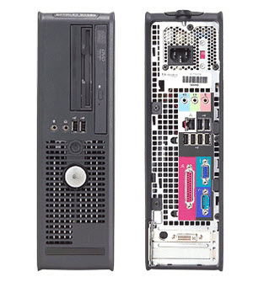
2. Clearly label the following components (using arrows) on your image of the back of a typical PC tower case:
   1. Power cord and power switch
   2. Monitor Interface (VGA or DVI or HDMI)
   3. Mouse Interface (USB or PS/2)
   4. Keyboard Interface (USB or PS/2)
   5. USB Ports
   6. Audio Inputs / Outputs
   7. Ethernet Interface

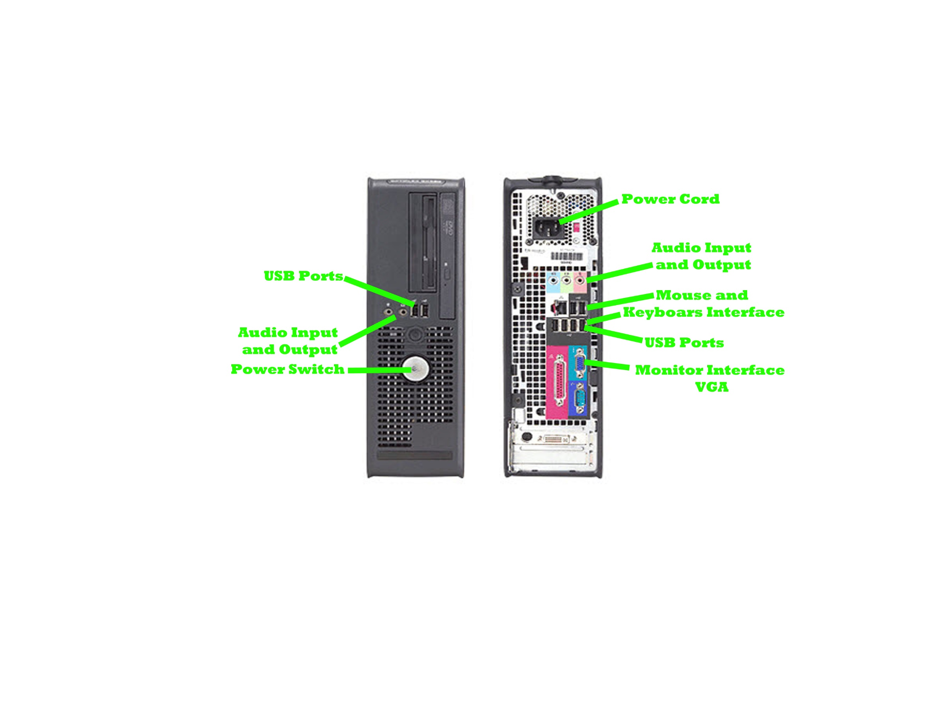

1. Research more in-depth about “Monitor Technology”. Make notes on the following:
   1. What different versions are currently available (e.g. VGA / DVI, Flat Panel Technology))

There are 3 different types of Monitor versions available. One version is the CRT monitor and these monitors are highly reliable and efficient and can generate a resolution of up to 2048 x 1536 pixels. CRT is mainly used in old TVs before the LEDs and LCDs. Another monitor is the LCD monitor and these monitors are compact, lightweight, and do not take up much desk space. LCD monitor do not use too much electricity and they are ecofriendly. The last monitor is the LED monitor and they produce images with a very high contrast and the images are very clear. LED monitors are known to be the best type of monitors because they are very thin, and they do not produce much heat when running.

* 1. How the component has changed since the 1980’s (e.g. Display Resolution, Technology)  
     The early monitors in the 1980s were not that clear and they did not have that much contrast. Monitors started to become clearer with a greater resolution when the LCD was introduced. The first LCDs were very expensive but overtime they became cheaper for the common household. More colors were visible on the LCD monitors than the older CRT monitors. Monitors became clearer, thinner and the screens became bigger.

1. Research more in-depth about “External Portable Storage”. Make notes on the following:
   1. Floppy Disks

Floppy disks are made of a thin and flexible magnetic storage materiel. Floppy disks are used to store data in hardware object. Floppy disks were used in the 1970s, but they are not needed anymore as computers have become better. Before RAM was invited, Floppy disks were the way to store data.

* 1. CD-ROM / DVD / Recordable CD/DVD

DVD is used for data storage and as a platform for multimedia. DVD was used to play recorded multimedia such as movies. It was also used a place to store data from a computer. Blu-ray has become more popular than DVD as it has a higher quality.

* 1. USB Memory Drives

USB are used to store data outside the computer. USBs offer a lot of storage space some time up to 100Gb. USBs are still used today to share data with other people.

* 1. Compact Flash Memory

These are used as a place to store data outside the computer. These are small but they can have a lot of storage space. The maximum capacity is 512Gb. These are used mainly in cameras to hold Video data and then to transport to a computer. These are still used today and are very popular in cameras.

* 1. Cloud Based Storage  
     Cloud storage means that data is stored over the internet in a cloud and it could be accessed by any devise added to the cloud. This is the main way most people store information in the 2010s as the internet is becoming better and more accessible. This is not the safest way to store data as hackers could hack into the cloud through the internet. But this way is the easiest way to store data.

**Level 4: PC Component Presentation**

**Outline**

Explore the development and features of a specific PC hardware component through deeper research and investigation. Work in partners to create a short presentation. Deliver the presentation to the class.

Each group will research a unique PC hardware component. Your specific topic will be assigned from the list provided below.

**Presentation Structure**

1. Explain what the PC component does and how it fits together with other components to make up a fully functioning PC.
2. Explain how the PC component works. Provide a diagram (image) showing the main parts of the component.
3. Research the current state of the art of the component in terms speed, capacity (size), and other related factors.
4. Research on-line suppliers that sell the PC Component. List the specifications for the available products and the cost (price).
5. Research how the PC component has changed and evolved since the early days of PCs in the 1980’s. Cover each of the following topics separately:
   1. Component Speed
   2. Component Size / Capacity
   3. Two other specifications specific to the PC component (ask Mr. Nestor)

**PC Component Topics**

|  |  |  |
| --- | --- | --- |
| **Topic** | **Partner 1** | **Partner 2** |
| CPU Microprocessor Chip |  |  |
| Motherboard Layout |  |  |
| Computer Graphics |  |  |
| Sound & Audio |  |  |
| Hard Disk Drives |  |  |
| Removable Disk Storage |  |  |
| Network / Internet Connectivity |  |  |
| Mouse / Pointing Devices |  |  |
| Monitor & Display Technology |  |  |
| Printers & Output Technology |  |  |